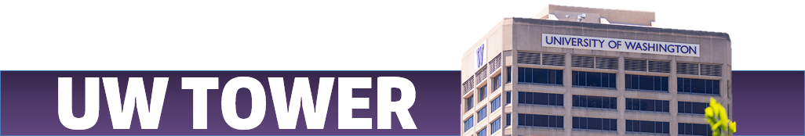
UW Tower Event Policies/General Information
These policies are for those that are interested in reserving UW Tower rental spaces. All reservations must end before 11pm with the reservation area being evacuated before 11:30pm. We may require 2 event staff if your event is over 100 people and/or serving food or alcohol.

Setup/cleanup

The requesting/hosting organization must leave the facility in a reasonable clean condition, remove decorations, reset furniture, and ensure the room is secured at the end of the event.

Decorations and other materials may only be hung to the tables, walls and doors using blue painter’s tape. The reserving RSO/department/organization is responsible for removing all tape, decorations and signs from the room and building and will be responsible for any damage caused to the facilities due to improper posting/hanging.

If you plan to have decorations, ABSOLUTELY NO nails, tape (except painters’ tape), open flames (includes no candles), or plug-in string/holiday lights, glitter, or confetti.

This policy also applies to, no loose confetti being allowed including:

Do not climb on the furniture. If you need assistance, please contact your dedicated event staff member(s) or UW Tower facilities.

The doors in the cafeteria cannot be locked & the fire exits must always remain clear. DO NOT block fire exits with furniture or equipment.

Fees may be applied if your event does not schedule a custodian and does not return the room back to its original state, and/or damages UW Tower property.

If the event space is left is disarray, examples including food being left behind, throw up needing to be cleaned up, or other types of debris there will be surcharge up to $200 added onto the signed quote amount.

Permit(s) Information – if pertains to your event

Serving Food/Drinks - A Temporary Food Service Permit is required to be filled out two weeks in advance if the event meets at least one of the following conditions:

Events that are being sponsored (meaning groups that are not UW affiliated) by UW departments and groups or

Events that are open to the public (students, faculty, staff and general public) or are advertised publicly or

Events sponsored by non-UW groups if campus community members are invited guests

Link: https://ehs.washington.edu/workplace/food-safety-program/temporary-food-service-permit

To Serve Alcohol - you must complete the UW Alcohol Service Request Form AND WA State issued banquet permit as soon as possible. Link for more information:

To submit the UUF Form: https://uwspecialprograms.org/alcohol-service/

WA State issued Special Occasion License can substitute for this as well

If you are an outside organization that is not affiliated with UW (student organizations count), or if your event is open to the public, you must fill out the UUF Form no later than two weeks in advance of your event.

Link: https://uwspecialprograms.org/uuf-info/

